Table of Contents
Trigonometric identities | Pages 2-3
Algebra | Page 4
Properties of Logarithmic Functions | Page 5
Cost, Revenue, Profit | Page 6
Marginal Average Cost, Revenue, and Profit | Page 7
Relative Rate of Change | Page 7
Elasticity | Page 8
Continuity | Page 8
Horizontal and Vertical Asymptotes | Page 8
Finding Absolute Max/ Mins for a Continuous Function f on a Closed Interval [a, b] | Page 9
Continuous Compound Interest | Page 9
The Definite Integral Symbol | Page 10
Fundamental Theorem of Calculus | Page 11
Average Value of a Continuous Function | Page 11
Area Between Two Curves | Page 11
Second-Derivative Test For Local Extrema | Page 11
Double Integral | Page 12
Average Value Over Rectangular Regions | Page 12
Unit Circle | Page 13

TRIGONOMETRIC IDENTITIES
Relations Between Trigonometric Functions
${\sin^{2}\left(θ\right)+cos}^{2}\left(θ\right)=1$
$\tan^{2}{(θ)}+1=\sec^{2}{(θ)}$
$\cot^{2}\left(θ\right)+1=\csc^{2}{(θ)}$
$\sec\left(θ\right)=\frac{1}{\cos\left(θ\right)}$ $\csc\left(θ\right)=\frac{1}{\sin\left(θ\right)}$
$\tan\left(θ\right)=\frac{\sin\left(θ\right)}{\cos\left(θ\right)}$ $\cot\left(θ\right)=\frac{\cos\left(θ\right)}{\sin\left(θ\right)}$
Negative Angle
$$\sin\left(-θ\right)=-\sin{(θ})$$
$$\cos\left(-θ\right)=cos⁡(θ)$$
$$\tan\left(-θ\right)=-tan⁡(θ)$$
Addition and Subtraction of Angles
$\sin\left(\frac{π}{2}±θ\right)=cos⁡(θ)$
$\cos\left(\frac{π}{2}+θ\right)=-sin⁡(θ)$
$\cos\left(\frac{π}{2}-θ\right)=sin⁡(θ)$
$$trigfunc\left(θ+2π\right)=trigfunc(θ)$$
Double and Half Angle Formulas
$\sin\left(2θ\right)=2\sin\left(θ\right)cos⁡(θ)$
$$\cos\left(2θ\right)=1-2\sin^{2}\left(θ\right)=\cos^{2}{(θ)-\sin^{2}{(θ)}}$$
$\sin\left(\frac{1}{2}θ\right)=±\sqrt{\frac{1-cos⁡(θ)}{2}}$
$\cos\left(\frac{1}{2}θ\right)=±\sqrt{\frac{1+cos⁡(θ)}{2}}$
Sine and Cosine Squared
$\sin^{2}\left(θ\right)=\frac{1}{2} [1-\cos\left(2θ\right)]$
$\cos^{2}\left(θ\right)=\frac{1}{2} [1+cos⁡(2θ)$]
More Angle Relations
if A+B=90 :
$\sin\left(A\right)=cos⁡(B)$
$\cos\left(A\right)=sin⁡(B)$
$\sqrt{a^{2}-x^{2}} → x=a sin⁡(θ)$
$\sqrt{a^{2}+x^{2} } → x=a tan⁡(θ)$
$\sqrt{x^{2}-a^{2}}→ x=a sec⁡(θ)$

Algebra
${(a^{x})}^{y}=a^{xy}$ $a^{x/y}= \sqrt[y]{a^{x}}$
$a^{x}a^{y}=a^{x+y}$ $a^{x}a^{-y}=a^{x-y}$
$a^{-x}=\frac{1}{a^{x}}$ $\sqrt{xy}=\sqrt{x}\sqrt{y}$

Polynomial form:
$f\left(x\right)=$ $a_{n}x^{n}+a_{n-1}x^{n-1}+… +a_{1}x+a_{0}$
Where n is a positive integer

Properties of Logarithmic Functions
Let b, M, N, p, x be positive real numbers with b≠1
$\log_{b}{1=0}$ $\log_{b}\left(MN\right)=\log_{b}{M}+\log_{b}{N}$
$\log_{b}{b}=1$ $\log_{b}\left(\frac{M}{N}\right)=\log_{b}{M}-\log_{b}{N}$
$\log_{b}{b^{x}}=x$ ${\log_{b}{(M}}^{p})=p*\log_{b}{M}$
$b^{\log_{b}{x}}=x$ $\log_{b}{M}=\log_{b}{N} \overset{⇔}{ } M=N$

Do people know that this means “if and only if”?

Cost, Revenue, Profit
Definitions
$$C\left(x\right)≔Cost$$
$$R\left(x\right)≔Revenue$$
$$P\left(x\right)≔Profit$$
$$p\left(x\right)≔Price$$

$$P\left(x\right)=R\left(x\right)-C\left(x\right)$$
$$R\left(x\right)=x*p\left(x\right)$$
$$R\left(p\right)=x(p)*p$$
Marginal Cost: $C^{'}\left(x\right)= \frac{d}{dx}\left[C\left(x\right)\right]$
Average Cost: $\overline{C}\left(x\right)=\frac{C\left(x\right)}{x}$
Marginal Average Cost: $\overline{C'}\left(x\right)=\frac{d}{dx}\left[\overline{C}\left(x\right)\right]$

MAC2233 Business Calculus
Marginal Average Cost, Revenue, and Profit
1. C(x) = Cost as a function of x

2. R(x) = Revenue as a function of x = p(x) * x
where p(x) = the price-demand per unit
3. P(x) = Profit as a function of x = R(x) – C(x)
4. Marginal Cost = $\frac{d}{dx}\left(C\left(x\right)\right)=C'(x)$
5. Average Cost = $\overline{C}\left(x\right)=\frac{C\left(x\right)}{x}$
6. Marginal Average Cost = $\overline{C}'(x)$
where x is the number of units of product produced in some time interval. Equations 4. – 6. also apply to Revenue and Profit.
*Marginal Cost is the instantaneous rate of change of cost relative to production level.
*The marginal cost function approximates the exact cost of producing the (x+1)st item:
Marginal cost Exact cost
C’(x) ≈ C(x+1) – C(x)
Similar interpretations can be made for marginal revenue and marginal profit.

Relative Rate of Change
$$Relative Rate of Change=\frac{f'(x)}{f(x)}$$
$$Percentage Rate of Change= \frac{f'(x)}{f(x)}*100$$

Elasticity
$$E\left(p\right)=\frac{-p*f'(p)}{f(p)}$$
- If E(p) < 1, then the demand is INELASTIC.
  - Increasing price increases revenue
- If E(p) > 1, then the demand is ELASTIC.
  - Increasing price decreases revenue
- If E(p) = 1, then the demand is UNIT

Continuity
A function f is continuous at the point x = c if
- $\lim_{x→c}{f\left(x\right) exists}$
- f(c) exists
- $\lim_{x→c}{f\left(x\right)=f}$(c)
If one or more of the three conditions fails, then f is discontinuous at x = c. A function is continuous on the open interval (a,b) if it is continuous at each point on the interval.

Horizontal and Vertical Asymptotes
A line y = b is a horizontal asymptote for the graph of y = f(x) if: $\lim_{x→±∞}{ f\left(x\right)=b}$
A line x = a is a vertical asymptote for the graph of y= f(x) if: $\lim_{x→a^{±}}{ f\left(x\right)=±∞}$ or $\lim_{x→a}{f\left(x\right)= ±∞}$

Finding Limits at Infinity and Horizontal Asymptotes
If $\left(x\right)=\frac{a_{m}x^{m}+a_{m-1}x^{m-1}+…+a_{1}x+a_{0}}{b_{n}x^{n}+b_{n-1}x^{n-1}+…+b_{1}x+b_{0}}$ , a_{m}≠0 and b_{n}≠0
Then $\lim_{x→±∞}{ f\left(x\right)= \lim_{x→±∞}{\frac{a_{m}x^{m}}{b_{n}x^{n}}}}$
There are three possible cases for these limits:
- If m < n, then $\lim_{x→±∞}{ f\left(x\right)=0}$ and the line y = 0 is a horizontal asymptote for f(x).
- If m = n, then $\lim_{x→±∞}{ f\left(x\right)=\frac{a_{m}}{b_{n}}}$ and the line $y=\frac{a_{m}}{b_{n}}$ is a horizontal asymptote for f(x).
- If m > n, then each limit will be +∞ or -∞, depending on m, n, a_{m}, and b_{n}, and f(x) does not have a horizontal asymptote.

Locating Vertical Asymptotes
For vertical asymptotes, let $\left(x\right)=\frac{n\left(x\right)}{d\left(x\right)}$ , where both n(x) and d(x) are continuous at x = c. If at x = c the denominator d(x) is 0 and the numerator n(x) is not 0, then the line x = c is a vertical asymptote for the graph of f(x). (Note: zeros of factors on the numerator of f(x) are not vertical asymptotes.

Finding Absolute Max/ Mins for a Continuous Function f on a Closed Interval [a, b]
- Check to make certain that f is continuous over [a, b].
- Find the critical values in the interval (a, b).
- Evaluate f at the end points a and b and at the critical values found in step 2.
- The absolute maximum f(x) on [a, b] is the largest of the values found in step 3.

- The absolute minimum f(x) on [a, b] is the smallest of the values found in step 3.

Continuous Compound Interest
A = Pe^{rt}
Where: P = the initial amount, t = the Time in years,
r = the Annual nominal interest rate compounded continuously,
A = the Amount at time t,
If r is positive, then A > P. If r is negative, then A < P.

The Definite Integral Symbol
The definite integral of some function, f(x), is equal to the area under the curve from some point x = a to some point x = b. This is expressed as:
$$\int_{a}^{b}{f\left(x\right)dx}$$
Areas above the x axis are counted positively and areas beneath the x axis are counted negatively. If the curve f(x) is split into three areas: A, B, and C, and A and B were above the x axis and C was below the x axis, then the definite integral of f(x) from x = a to x = b is:
$$\int_{a}^{b}{f(x)dx}=A-B+C$$

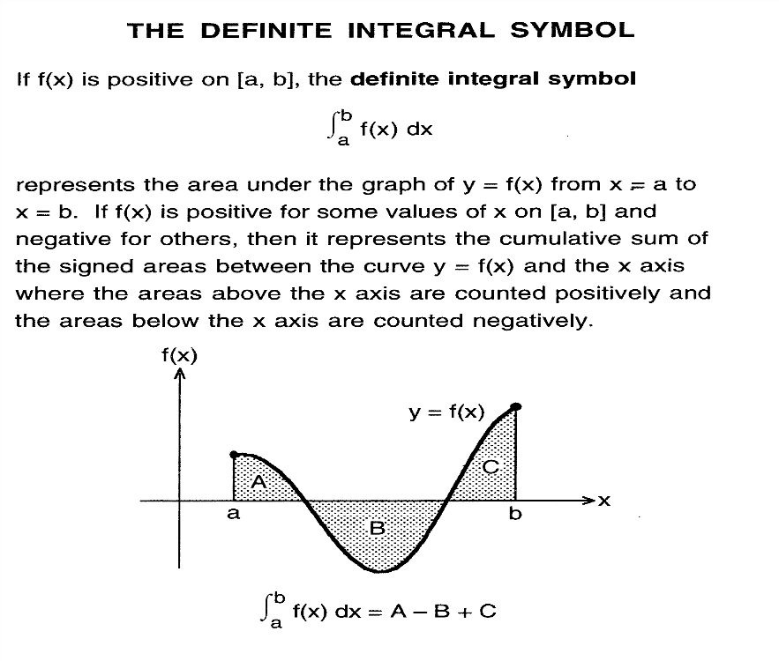

Fundamental Theorem of Calculus
If f is a continuous function on the closed interval
[a,b] and F is any antiderivative of f (i.e., F’(x)=f(x)), then:
$$\int_{b}^{a}{f\left(x\right)dx=F\left(x\right)|{b \atop a}}=F\left(b\right)-F(a)$$
Average Value of a Continuous Function
The average value of a cont. function over [a,b] is
$$\frac{1}{b-a}\int_{a}^{b}{f\left(x\right)dx}$$
Area Between Two Curves
Given two continuous functions f(x) and g(x), the area, A, between the two curves is defined as the integral of the upper curve minus the integral of the lower curve over the interval [a,b]
$$A=\int_{a}^{b}{\left[f\left(x\right)-g\left(x\right)\right]dx}$$
Where f(x) is the upper curve and g(x) is the lower curve.
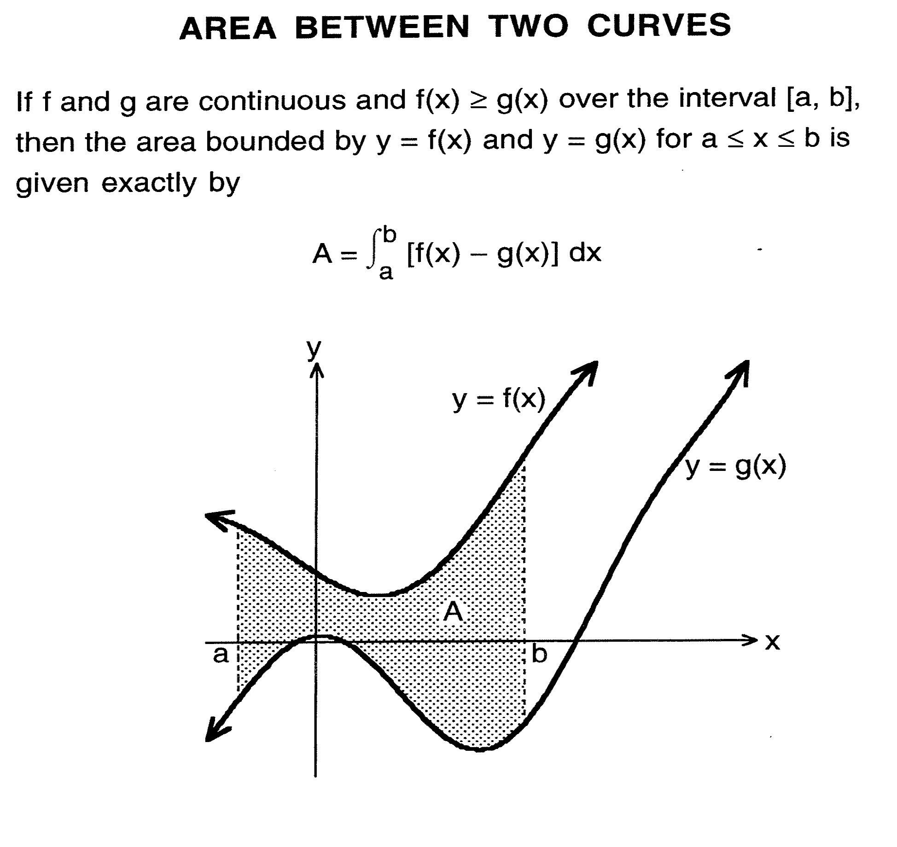

Second-Derivative Test For Local Extrema
Given:
- z = f(x,y)
- f_{x}(a,b) = 0 and f_{y}(a,b) = 0 [(a,b) is a critical point]
- All second-order partial derivatives of f exist in some circular region containing (a,b) as a center
- A = f_{xx}(a,b), B = f_{xy}(a,b), C = f_{yy}(a,b)
Then:
- If AC – B² > 0 and A < 0, then (a,b) is a local maximum.
- If AC – B² > 0 and A > 0, then (a,b) is a local minimum.
- AC – B² < 0, then f has a saddle point at (a,b)
- If AC – B² = 0, the test fails.

Double Integral
The double integral of a function f(x.y) over a rectangle R = {(x,y) | a ≤ x ≤ b, c ≤ y ≤ d} is
$$\iint_{R}{f\left(x,y\right)dA}$$
= $\int_{a}^{b}{[\int_{c}^{d}{f\left(x,y\right)dy}]}dx$
= $\int_{c}^{d}{[\int_{a}^{b}{f\left(x,y\right)dx}]}dy$

Average Value Over Rectangular Regions
The average value of the function f(x,y) over the rectangle R = {(x,y) | a ≤ x ≤ b, c ≤ y ≤ d} is
$$\frac{1}{\left(b-a\right)\left(d-c\right)}\iint_{R}{f\left(x,y\right)dA}$$

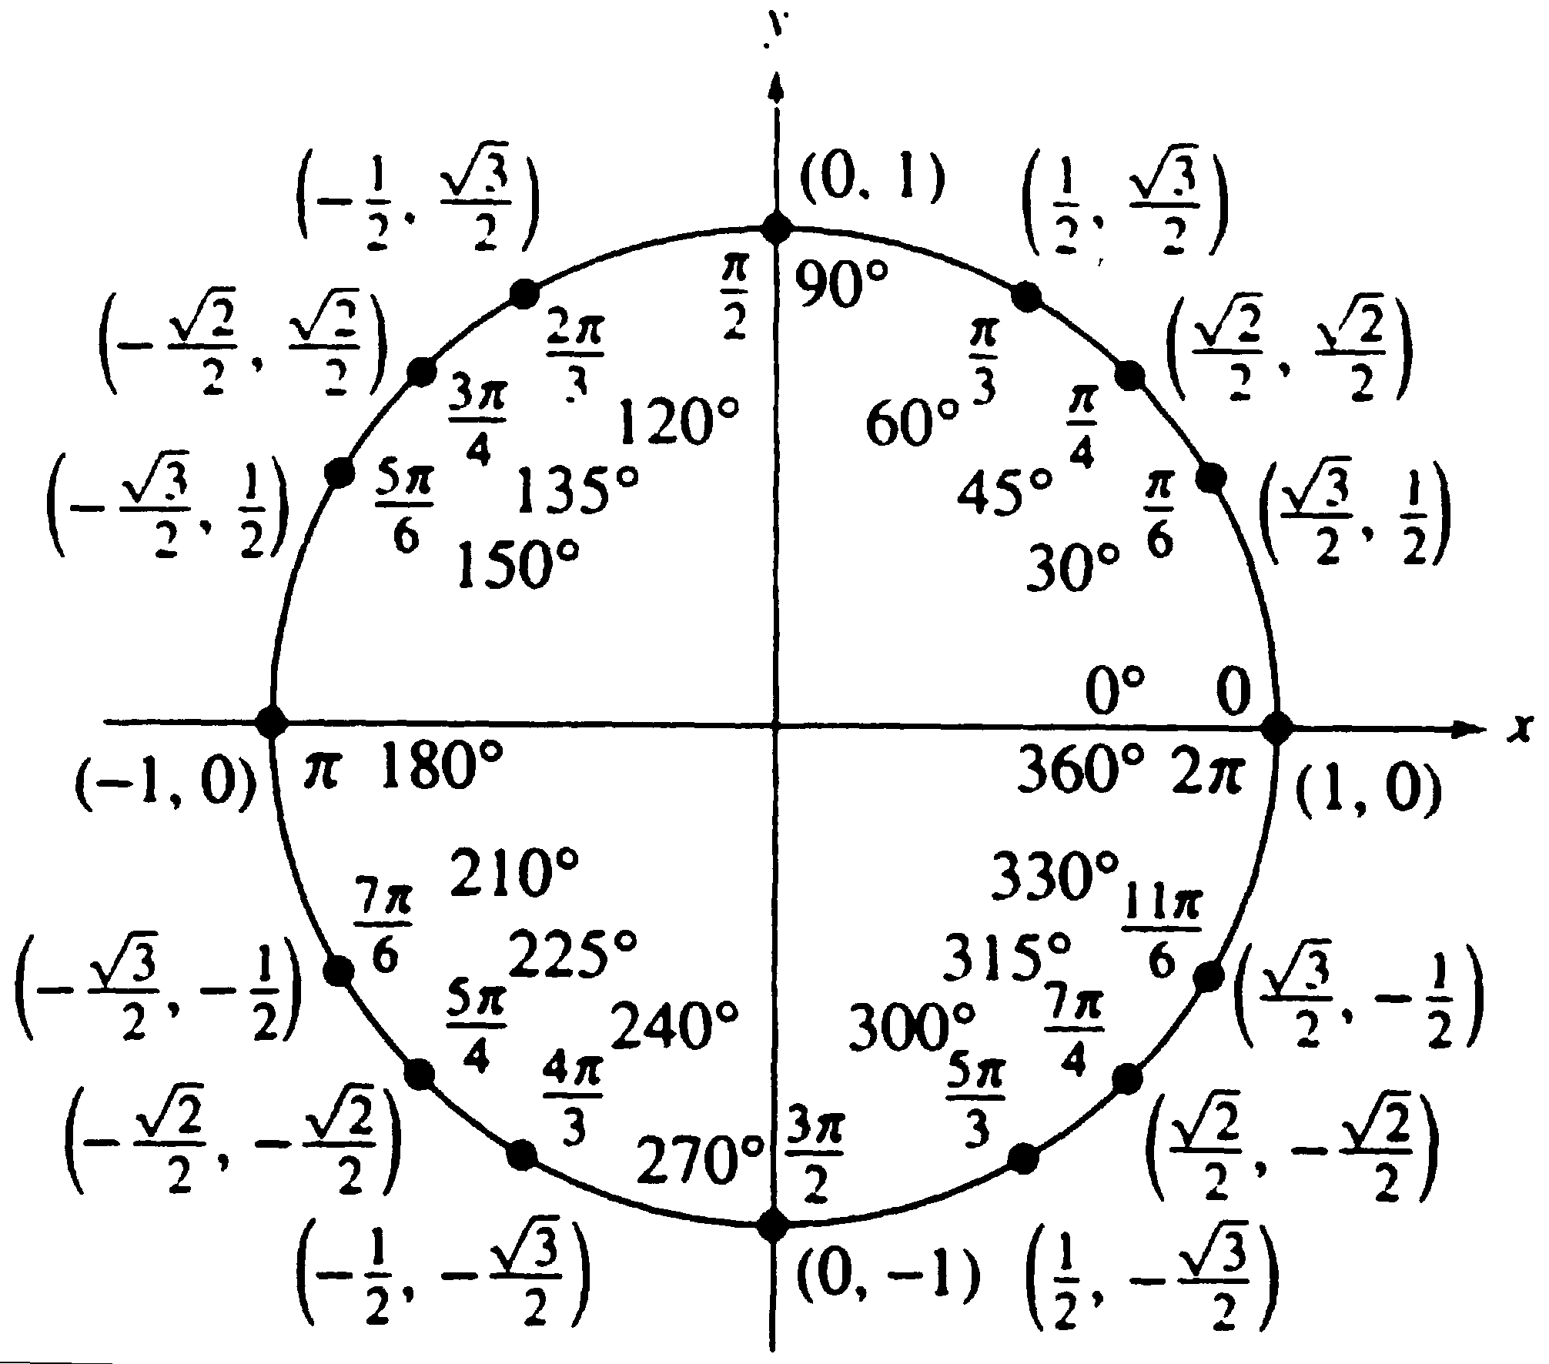
Angle | cos($θ$) | sin($θ)$ | tan($θ)$ | cot($θ)$ | sec($θ)$ | csc($θ)$
0 or$2π$ | 1 | 0 | 0 | Undefined | 1 | Undefined
$$\frac{π}{6}$$ | $$\frac{\sqrt{3}}{2}$$ | $$\frac{1}{2}$$ | $$\frac{\sqrt{3}}{3}$$ | $$\sqrt{3}$$ | $$\frac{2\sqrt{3}}{3}$$ | 2
$$\frac{π}{4}$$ | $$\frac{\sqrt{2}}{2}$$ | $$\frac{\sqrt{2}}{2}$$ | 1 | 1 | $$\sqrt{2}$$ | $$\sqrt{2}$$
$$\frac{π}{3}$$ | $$\frac{1}{2}$$ | $$\frac{\sqrt{3}}{2}$$ | $$\sqrt{3}$$ | $$\frac{\sqrt{3}}{3}$$ | 2 | $$\frac{2\sqrt{3}}{3}$$
$$\frac{π}{2}$$ | 0 | 1 | Undefined | 0 | Undefined | 1

